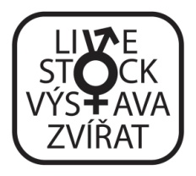
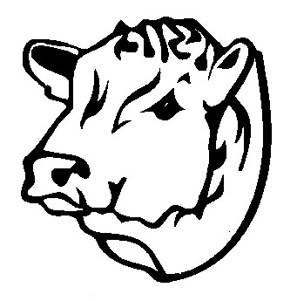
PROGRAM OF BEEF SHOWS
AND CHAMPIONSHIPS - Brno 2023
(BVV exposition fairground, hall P/ beef ring)

Saturday 22. 4. 2023

12,00 – 16,00 National championship of Aberdeen Angus
judge: Angus Stovold, breeder (Rosemead Angus) and president Aberdeen-Angus Cattle Society Scotland
16,30 – 18,00 Commented show and evaluation of the best animals – Dexter, Belgian Blue

Sunday 23. 4. 2023

10,00 – 14,00 National championship of Charolais
judge: Sébastien Cluzel, Herd-Book Charolais, France
14,00 – 17,00 National championship of Limousine
judge: Rikke Benoit, GAEC BENOIT, France

Monday 24. 4. 2023

10,00 – 12,00 National championship of Aubrac
judge: Laurent Antignac, Elite Export, France
12,00 – 14,00 National championship of Parthenaise
judge: Laurent Antignac, Elite Export, France
14,30 – 15,00 National championship of Gasconne
judge: Laurent Antignac, Elite Export, France
15,00 – 15,30 National championship of Salers
judge: Laurent Antignac, Elite Export, France
15,30 – 16,00 National championship or commented show of Blonde d’Aqutaine
judge: Association technician
16,00 – 18,00 Commented show and evaluation of the best animals – Galloway, Highland, Wagyu

Tuesday 25. 4. 2023

10,00 – 12,30 National championship of Beef simmental
judge: Mathias Gerber, breeder and chairman of Fleckvieh Fleisch WG Beef Simmental, Switzerland
12,30 – 13,15 National championship or commented show of Hereford
judge: Association technician
13,15 – 14,00 National championship of Piemontese
judge: Association technician
14,00 – 15,00 judging of beef breeding bulls
judge: Vítek Čepelák + Petra Pokorná, Czech Republic
15,00 – 16,00 judging of beef breeding groups
judge: Michal Janda + Radek Dobeš + Karel Šimák, Czech Republic
16,00 – 18,00 competition of Youth team ČSCHMS Praha

Wednesday 26. 4. 2023

10,00 – 15,00 Auction sale of pedigree heifers and embryos

